Login to MyGSeT Portal
This function allows the e-Services users who are given the User ID and password to login to MyGSeT Portal system. Once the user has successfully logged into the portal system, they will be able to use the portal services and facilities.
The following diagram shows the user login activities:
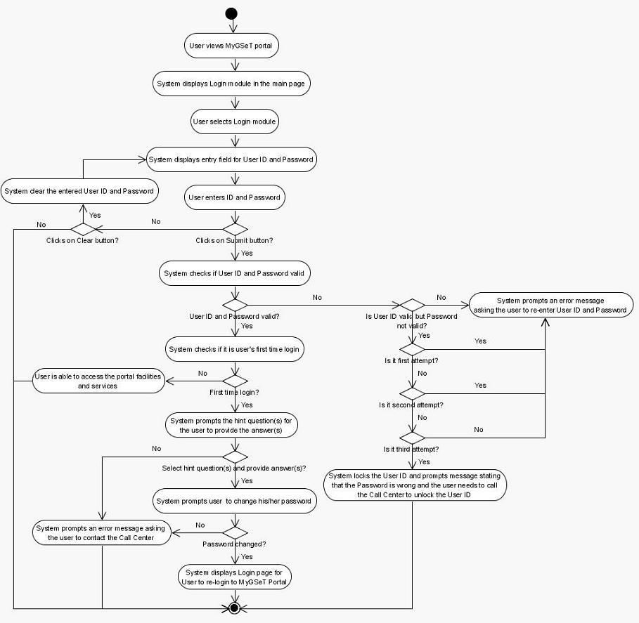
Figure 2.2-1: Login via User ID and Password Activity Diagram

Detailed Functional Description
- To login to MyGSeT Portal system, the user will click on the Login portlet in the main screen (refer Figure 2.2-2).
- The system will display the Login page (refer Figure 2.2-3).
- The system will provide two entry fields for the user to enter a valid User ID and password.
- The user must make sure that the following criteria are met:
  - User ID must be in sixteen (16) digits
  - Password must be eight (8) characters (alphanumeric).
- When the user clicks the ‘submit’ button, the system will check if the id and password are valid.
- If it is not a valid User ID and password the system will prompt an error message.
- If valid User ID is entered with wrong password, the system will display an error message ‘Invalid User ID/Password. Number of attempts left <n-1>’. The maximum attempt for the incorrect login is three (3).
- During the third time the password is wrong, the id will be locked. The system will display a message saying that the password is wrong and the user needs to call the Call Centre to unlock the User ID.
- If the User ID and password are valid the system will check if it is the first time e-Services user login into the portal.
- If it is the first time user login, the system will prompt the e-Services user to select a maximum of three (3) hint questions and provide answers to the selected hint questions (refer to Figure 2.2-4).
- If the user does not change password, the system will prompt an error message requesting the user to change the password.
- If it is not the first time login, the user will be able to access the portal facilities and services (refer to Error: Reference source not found).
- For the first time login, the user needs to login again to the MyGSeT Portal to be able to access the portal facilities and services.

Screen Design & Data Description
The following figure shows the screen design for the login portlet:
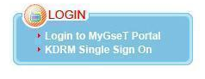
Figure 2.2-2: Screen Design for Login portlet
The following is the list of items displayed on the screen in the login function:
Item | Type | Description
 | None | This is a hyperlink for the e-Services users to login to MyGSeT Portal (refer to Figure 2.2-3)
 | None | This is a hyperlink is for the KDRM users to login to MyGSeT Portal.
Table 2.2-1: Data Description for Login portlet

The following figure shows the screen design for the login module:
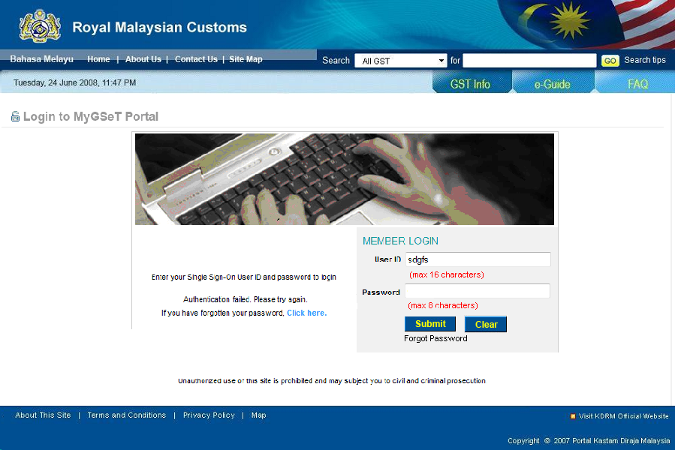
Figure 2.2-3: Screen Design for Login module
The following is the list of items displayed on the screen in the login function:
Item | Type | Description
User ID | Character | This is an entry field for the User ID. The maximum length of the User ID is sixteen (16).  This is a mandatory field.
Password | Character | This is an entry field for the user to key in a password. The maximum length of the password is eight (8).  This is a mandatory field.
 | Button | This button is for the user to submit their User ID and Password.  This button will be enabled only when the User ID and password fields have values.
 | Button | This button is for the user to clear their User ID and Password.  This button will be enabled only when the User ID and password fields have values.
 | Hyperlink Text | This is a hyperlink for the user to click if they forgot their password. When the user clicks this hyperlink, the Forgot Password screen will be displayed (refer to Error: Reference source not found).
Table 2.2-2: Data Description for Login Screen

The following figure shows the screen design for the first time login user:
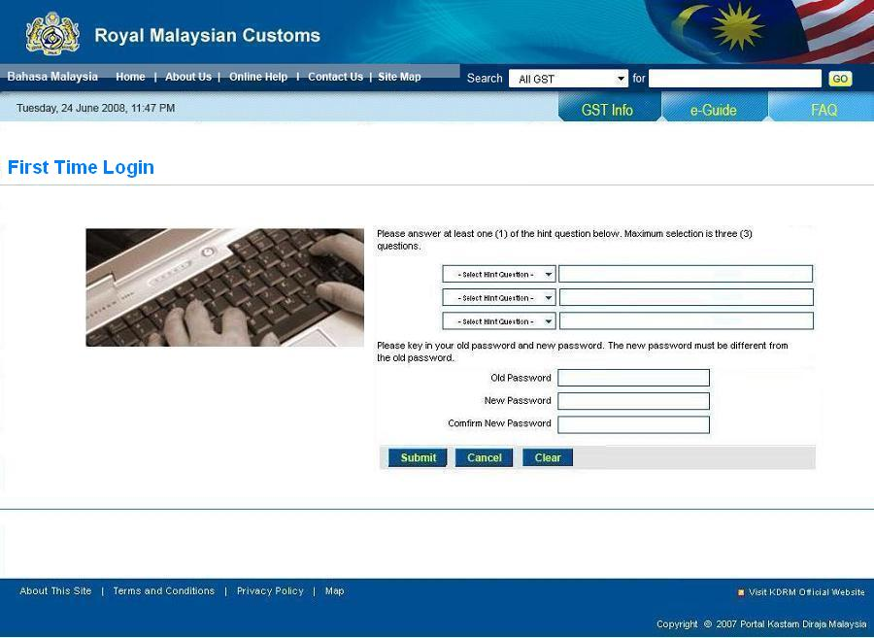
Figure 2.2-4: Screen Design for First Time Login User
The following is the list of items displayed on the screen in the first time login function:
Item | Type | Description
Hint questions | Drop down list | The user is allowed to select at least one (1) and up to three (3) hint questions and provide the answer(s). This is a mandatory field.
Old Password | Character | This is a mandatory entry field for the user to key in the old password.
New Password | Character | This is a mandatory entry field for the user to key in the new password.
Confirm New Password | Character | This is a mandatory entry field for the user to confirm the new password.
 | Button | This button is for the user to save the new password.
 | Button | This button is for the user to cancel the current activity. When clicking this button, the login page will be displayed (refer to Figure 2.2-3: Screen Design for Login module).
 | Button | This button is for the user to clear all fields.  This button will be enabled only when any entry fields have values.
Table 2.2-3: Data Description for First Time Login Screen

